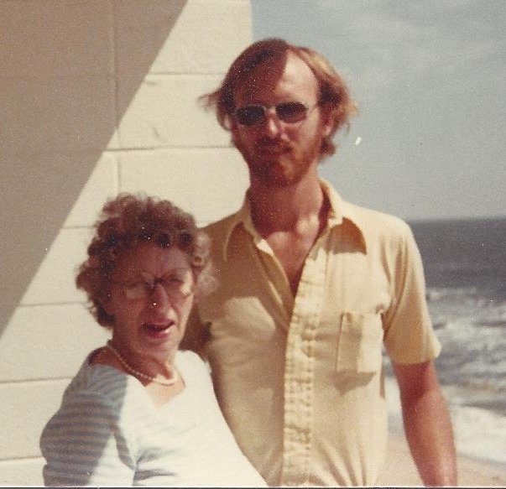

Mary Foster Wolfe and Dan Harrington – 1979

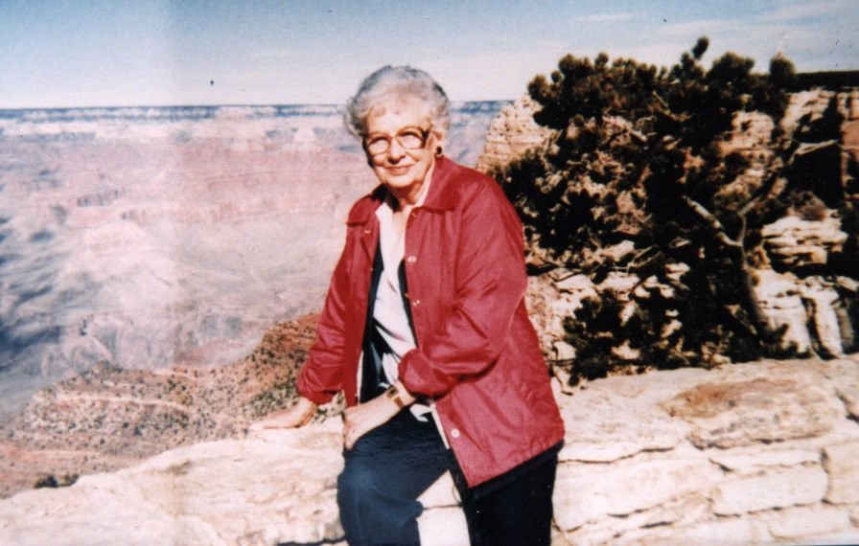

Audra Lavada Young Harrington, mother of

Richard E. Harrington – Arizona – 1985